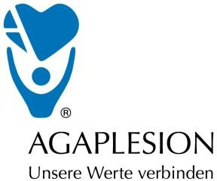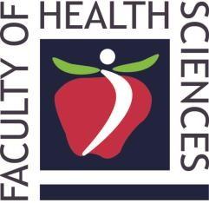

Contact person:

Dr. Orsolya MÁTÉ
senior lecturer
Head of International Affairs
University of Pécs
Faculty of Heath Sciences, 4. Vörösmarty Street, H-7621 Pécs
+36 72 513-670/677 Fax: +36 72 513-671

E-Mail: orsolya.mate@etk.pte.hu

Application Form for the MNE study tour

By completing and signing the Application Form, I will apply for the study tour organized by the MNE Foundation in Frankfurt am Main.
Name
Date of birth
Adress
Mobile number
E-Mail adress
Nationality
Valid identity document | - yes ID/Passport number:  - no

Special needs during the catering:
- pork-free menu
- vegetarian menu
- food allergies:

Date Signature of participant

